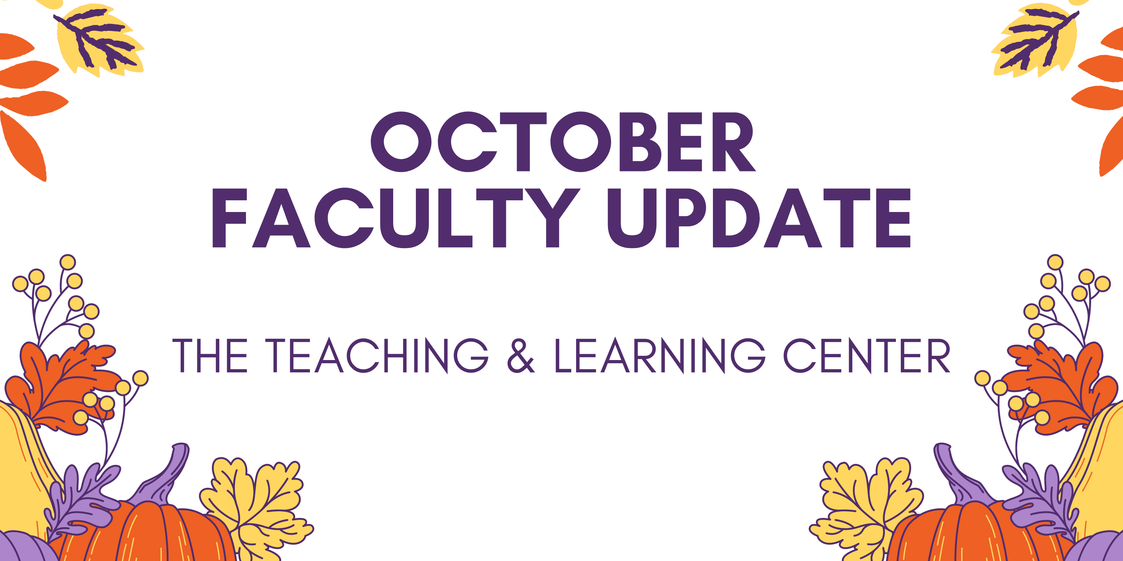

Open Initiatives

Registration Open: Padlet Pilot Program
The Teaching & Learning Center is excited to announce the new Padlet Pilot Program! Padlet is an online visual board that can be used to organize and share content. It’s a great tool for facilitating both collaborative and individual activities and projects. The Teaching & Learning Center has procured a trial license, complete with D2L Integration, through December 31, 2023.

Registration for the Padlet Pilot Program is open through Monday, October 23rd. Please visit the Padlet Pilot Program page of our website for more information about the program and how to register!

Upcoming Events & Workshops

New! Teaching Strides
Join us this Fall for a new professional development opportunity that combines physical activity with meaningful conversation! Each Tuesday, meet at the Ram Statue in front of Old Library at 11:30 am to join us for a discussion on a teaching related topic or theme as we walk around campus. To learn more, visit our website.
Not interested in walking, but still want to talk about the week’s teaching topic? Join us on Wednesday at 11:30 on Zoom for 30 minutes of conversation around each week’s topic.
- 09/12 - Student Engagement Strategies
- 09/19 - Effective Assessment Methods
- 09/26 - Balancing Teaching and Research
- 10/03 - What to Do about AI?

Registration Open: Teaching with AI Webinar Series
Build your AI literacy by attending a three-part webinar series on incorporating AI tools and strategies into your instructional practice. Hosted by TLC staff, these hour-long Zoom sessions start with a brief overview of generative AI, spend 30 minutes on the session’s topic, and end with time for questions and conversation. The first workshop will focus on Creating Learning Activities and will be held on Friday, October 13 at 10:00am. Register for one or both remaining webinars!

Save the Date: Faculty Fusion
Save the Date for Faculty Fusion!
- When: January 17, 2024 from 9:00am to 1:00pm
- Where: The Foundation
- What: An in-person set of three interactive panels covering hot topics to help you prepare for the new semester.

Panel topics for this winter's event include:
- Pedagogy of Care: Supporting Mental Health through Instructional Practices
- Using AI for Teaching
- Addressing Micro-Aggressions in the Classroom
Each session has 30 minutes of presentation from a faculty panel followed by 20 minutes of Q&A and table conversations with your peers.

Are you interested in being a faculty panelist for one of our topics? Complete the call for interest form by Monday, November 6, and a member of the TLC staff will reach out to learn more about your expertise and ideas.

Program Updates

Online Faculty Development Program
Congratulations to Mark McKibben for being the first faculty to complete the new and improved, self-paced Online Faculty Development Program!

Faculty interested in completing OFD can now self-enroll into the program’s D2L site using the Discover feature and start working when it fits their schedule. More details are available in the New OFD Announcement. If you have any questions about these changes, please contact the Teaching and Learning Center.

If you are interested in serving as a peer reviewer for new OFD modules currently under development, please complete the peer reviewer interest form. Selected faculty would spend 2 to 3 hours reviewing content drafts of new modules, providing their feedback and perspective.

Stay Connected

Help Us Find Work Study Students
If you know of a student looking for a work study opportunity, the TLC is looking to hire 10 students at five hours a week to be inaugural participants in a new program. Students should use Handshake to review the position details and submit an application.

ODLI on Air Podcast
WCU faculty do amazing things. Check out their stories on the ODLI on Air podcast!
- Bringing Empathy to Nursing Education using 360 Video with Dr. Nancy Barker & Dr. Danielle Yocom
- Ram Poll: Gauging Student Opinion Across the State with Dr. Laura Pyott
If you are interested in being a guest on the show, email us at tlc@wcupa.edu.
Want to record your own podcast? The audio recording studio is available for reservations.

Connect with Us
The Teaching and Learning Center is far more than just a newsletter! Our website hosts a variety of teaching resources and our full Event Calendar. To get in touch, feel free to send us an email, or stop by our drop-in hours to speak live with one of our designers.

