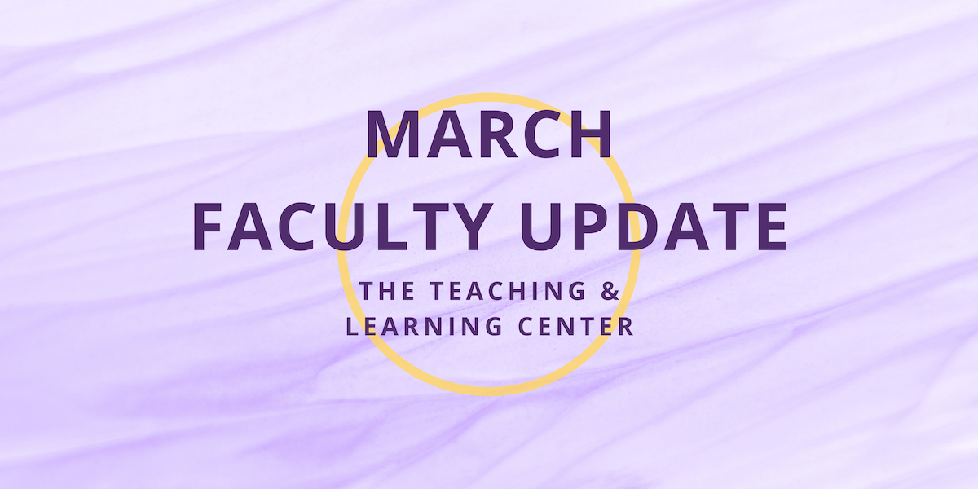

Open Initiatives

Research Study on Teaching with Generative AI
The Learning Center (TLC) is conducting a survey of faculty members’ perceptions of generative AI. The results of the study will help inform the Learning Center (TLC) regarding the support faculty members need to deal with generative programs to teach. Dr. David Bolton (CESW) and Dr. Esther Smidt invite you to participate in this study by completing this Faculty AI survey. The deadline has been extended to Sunday, March 31. Your participation is most appreciated.

Spring 2024 Adjunct Faculty Cohort Mentoring Program
Join seasoned adjunct faculty mentors for discussion and Q&A discussing professional development related to teaching, scholarship, and service, and as a bonus, build your community at WCU! Sign up online to meet with a faculty mentor during a convenient one-hour time slot over Zoom this March and/or April.

All adjunct faculty are invited to join the program. Additional details can be found on the Spring 2024 Adjunct Faculty Mentoring flyer, and any questions can be directed to Innhwa Park (ipark@wcupa.edu), Yanan Chen (ychen@wcupa.edu), Laura Fiorenza (lfiorenza@wcupa.edu), or Vipanchi Mishra (vmishra@wcupa.edu).

Teaching Strides
Last call! Join up with your colleagues to discuss teaching topics while taking a walk around campus! To better accommodate busy schedules, we are asking those interested in participating to sign up, and then we will work to find a common time for our weekly walk.

Upcoming Events & Workshops

Generative AI Webinars
Enhance your Generative AI literacy by attending a TLC AI webinar! These hour-long Zoom sessions will start with a brief overview of a generative AI tool, spend 30 minutes on the session’s topic, and end with time for questions and conversation. Both sessions will begin at 12:30pm.
- Ethical Considerations of Generative AI: Thursday, March 21
- Enhancing Your Productivity with Generative AI: Thursday, April 25
Register for one or both webinars today, or if you can't attend, check out the recordings on our blog the week after the event.

Celebration of Teaching: Call for Proposals
The TLC invites proposals for two events taking place during our Celebration of Teaching:
- Facilitate a 30-minute hands-on small group mini-workshop demonstrating a teaching technology or teaching technique.
- Present a teaching concept, idea, strategy, or activity at the Teaching Excellence Showcase.
For more details on both events, see the Proposal Submission Form. Proposals are due by Sunday, March 31.

Faculty Mentoring & PETAL Celebration: Save the Date
Join the Faculty Mentoring Program and the inaugural PETAL class for an end of year celebration on Friday, May 3! Information on how to RSVP will be forthcoming in April.

Celebration of Teaching: Save the Date
Incredible teaching happens every day across WCU! Join us on Tuesday, May 7 for a series of four events to sample and discover new WCU teaching innovations, dialog with peers on teaching topics, and celebrate the teaching excellence that happens across WCU. The day's events will include mini-workshops, our 9th annual Teaching Excellence Showcase, a virtual keynote presentation, and the TLC Teaching Awards Ceremony. We hope to see you there!

Applying the Quality Matters Rubric (APPQMR) Training
This full day, in-person workshop will renew your CAPC Distance Education Training Credential and award you the official Quality Matters APPQMR Certificate of Completion. It is facilitated by WCU instructional designers. The training will be held on Wednesday, May 15 from 8:30am to 4:00pm; participants must attend the whole day. Complete the APPQMR Interest Form, and a member of the TLC will be in contact a few weeks prior to the workshop.

RECAP: Save the Date
Join us at the 29th Annual RECAP Conference on Thursday, May 16 for a day of inspiration, knowledge exchange, and networking! Hosted by Information Services & Technology in partnership with the TLC, this event promises to be a showcase of reliable strategies, transformative technologies, and innovative pedagogical approaches that are shaping the future of higher education.

To learn more, visit the RECAP site, or register for RECAP today!

Program Updates

Technology Roundup – Spring 2024
Check out the first edition of the Technology Roundup! This feature will be released on the TLC blog each Spring and Fall Semester with the purpose of keeping our WCU teaching and learning community informed on the latest instructional technologies.

Online Faculty Development Program
Need to earn or renew your CAPC distance education credential? Faculty can now self-enroll into the OFD program’s D2L site using the Discover feature! Start working whenever it fits your schedule.

Stay Connected

ODLI on Air Podcast
The podcast surpassed over 1,000 listens, so thank you to all who are partaking of episodes highlighting the great work of WCU faculty! Recent episodes shared President Fiorentino’s 45 years of experience at WCU and the perspectives of faculty who have been at WCU for just a single semester. Moving into March, episodes will highlight the development of an online training module to evaluate online sources and teaching via livestreaming. Give one of our episodes a listen today!

Connect with Us
The Teaching and Learning Center is far more than just a newsletter! Our website hosts a variety of teaching resources and our full Event Calendar. To get in touch, feel free to send us an email, or stop by our drop-in hours to speak live with one of our designers.

