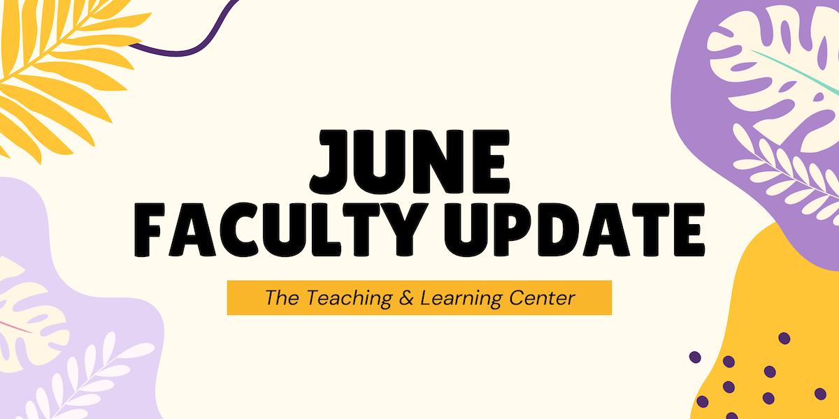

# Open Calls & Initiatives

## (Due Jul 31) Pedagogical Innovations Faculty Learning Community

The Teaching and Learning Center (TLC) and the Office of Research and Sponsored Programs (ORSP) are pleased to invite expressions of interest for the 2025-2026 Pedagogical Innovations Faculty Learning Community (FLC). Selected participants will join an interdisciplinary community of peers to design and implement studies examining innovative teaching strategies.

This year-long program requires participants to attend monthly meetings throughout the fall and spring semesters featuring structured opportunities for peer consultation, collaborative problem-solving, and scholarly exchange. Expressions of interest are due **Thursday, July 31.** For complete program details and submission guidelines, please visit our website.

## (Due Aug 18) Fall ACUE Courses: Registration Open

PASSHE is pleased to offer fall courses for faculty in partnership with the [Association of College and University Educators (ACUE)](https://acue.org/). These courses are part of ACUE's Effective Online Teaching Practices (EOTP) pathway. In EOTP courses, faculty will learn and implement evidence-based teaching practices proven to boost student persistence and completion, aligning with PASSHE's future institutional initiatives of course and program sharing.

The EOTP pathway provides WCU faculty with an alternative option for DE certification or recertification. For DE certification, faculty must complete courses in the series along with the capstone module in the OFD program. For DE recertification, completion of courses in the series is sufficient.

Registration is open now until **Monday, August 18.** To apply, please visit [PASSHE's ACUE registration webpage](https://portal.acue.org/pages/passhe) and click Apply Now.

## (Due Sep 5) Teaching Circle: Classroom Conversations

Ever wondered about the distinctions between discussions, debates, and dialogues in your classroom? Join our fall teaching circle to explore these conversational approaches as pedagogical strategies. We will meet monthly to share what works (and what doesn't) for engaging students and consider which approach fits different learning situations. No expertise required—just bring your curiosity and classroom stories! To learn more and register, visit [our website](https://www.wcupa.edu/tlc/flc.aspx).

## (Ongoing) Seeking Faculty Teaching Exemplars

The TLC is seeking faculty interested in sharing examples of learning activities which work well in remote synchronous classes to enhance the Online Faculty Development Program (OFD) remote synchronous module. We are looking for faculty with example activities that fit one of these concepts:

* Community Building Activities
* Chat
* Polling
* Individual Problem Solving
* Socratic Seminar
* Debate
* Video
* Games
* Entrance/Exit Tickets

If you have an example and are willing to work with us to create a short video about it, please contact Tom Pantazes ([tpantazes@wcupa.edu](mailto:tpantazes@wcupa.edu)).

## (Ongoing) Call for Mentors

## Are you looking for a university-level service opportunity? Do you want to make a significant difference in a colleague’s career development? Do you want to increase your own job satisfaction? Consider becoming a mentor with WCU’s Faculty Mentoring Program. The Faculty Mentoring Committee seeks faculty to serve as mentors for untenured faculty, faculty seeking promotion, and adjunct faculty. [Learn more about qualifications and expectations](https://wcu-tlc.org/pd/call-for-faculty-mentors/), read about [recent FMC events](https://wcu-tlc.org/pd/faculty-mentoring-committee-panels-on-scholarly-productivity-and-promotion/), or [sign up to participate in mentor training](https://wcupa.co1.qualtrics.com/jfe/form/SV_6J68tOnrJHyuajk).

# Upcoming Events

## (Ongoing) Online Faculty Development Program

Need to earn or renew your CAPC distance education credential? Faculty can now self-enroll into the OFD program’s D2L site using the [Discover feature](https://wcupaprod.service-now.com/kb?id=kb_article_view&sysparm_article=KB0010869)! Start working whenever it fits your schedule.

# Stay Connected

## Connect with Us

The Teaching and Learning Center is far more than just a newsletter! Our website hosts a variety of [teaching resources](https://www.wcupa.edu/tlc/teaching-resources.aspx) and our full [Event Calendar](https://www.wcupa.edu/tlc/events.aspx). To get in touch, feel free to [send us an email](mailto:tlc@wcupa.edu?subject=), or stop by our [drop-in hours](https://www.wcupa.edu/tlc/drop-in.aspx) to speak live with one of our designers.