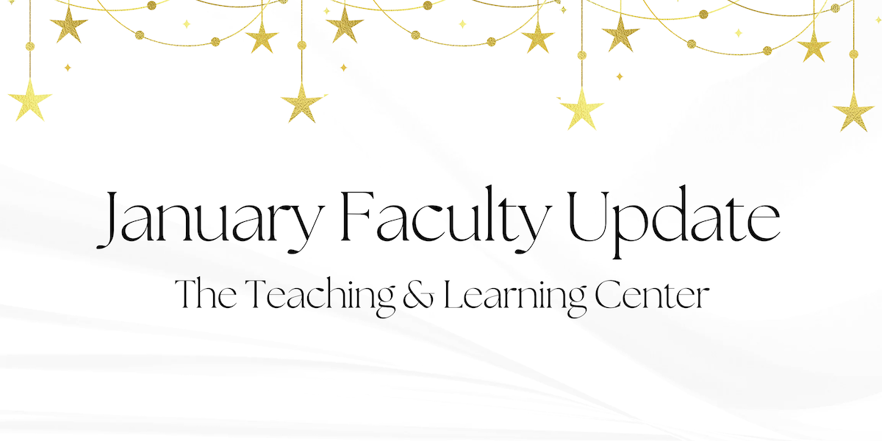

Welcome back, and happy New Year! We're excited to reconnect with all of you and continue our work together in the rapidly approaching spring semester. If you'd like a hand getting back into gear for classes, don't forget to reach out to your instructional designer, or join us and some of your wonderful colleagues at [Faculty Fusion](https://wcu-tlc.org/pd/2025-faculty-fusion-hot-topics-with-the-tlc/) next Wednesday! As always, you can find some great resources on [our website](https://www.wcupa.edu/tlc/), and while we've highlighted a few programs and events we're excited about below, you'll find the latest updates on everything going on at the Teaching & Learning Center on [our blog](https://wcu-tlc.org/).

# Open Calls & Initiatives

## (Due Jan 31) Teaching Circle: Power, Privilege, and Inequality

The Teaching and Learning Center (TLC) invites you to join our Spring Teaching Circle focused on teaching about systems of power, inequality and privilege. The idea for this teaching circle was inspired by conversations with colleagues who wanted to connect with others who are teaching about power, privilege and structural inequalities in their courses.

Faculty at all experience levels who may currently or plan to teach courses on historically marginalized groups and structural inequalities or want to incorporate these topics into existing courses are welcome to participate. To learn more, [visit our website](https://www.wcupa.edu/tlc/flc.aspx), or to express interest in participating, complete the [online registration form](https://wcupa.co1.qualtrics.com/jfe/form/SV_1YpZyffkNk0qV2C) by **Friday, January 31**.

## (Due Jan 31) Teaching Triangles: A Peer Observation Program

The Teaching Triangles program involves three faculty members in a triad who agree to visit each other’s classes over the semester and meet to discuss what they have learned about their own teaching from the observations. The process is non-evaluative, and the program is open to all WCU faculty, including adjuncts. Learn more about the program [on our website](https://www.wcupa.edu/tlc/flc.aspx) or [from our podcast, ODLI on Air](https://open.spotify.com/episode/7EVYwGZvoqtNBIDy4jiaDa?si=w5eFVVtcRCW6k0ulgMs-rw&nd=1&dlsi=7e683d93f8334283). If you're interested, [apply online](https://wcupa.co1.qualtrics.com/jfe/form/SV_02LR8pktqgLt5ye) by **January 31.**

## (Due Feb 17) Join CELT’s Spring Book Club

This semester, the CELT Book Club will be reading [*Grading for Growth: A Guide to Alternative Grading Practices that Promote Authentic Learning and Student Engagement in Higher Education*](https://www.routledge.com/Grading-for-Growth-A-Guide-to-Alternative-Grading-Practices-that-Promote-Authentic-Learning-and-Student-Engagement-in-Higher-Education/Clark-Talbert/p/book/9781642673814) by David Clark and Robert Talbert (2023). This book targets faculty interested in exploring alternative forms of learning assessment as well as those currently using alternative grading systems who are looking for ideas and options to refine practice.

[Sign up now to reserve your spot!](https://wcupa.co1.qualtrics.com/jfe/form/SV_dgTLZU75mulGH2e) We will provide participants copies of the book if you can commit to attending two meetings on Zoom, one in February and one in April. For more information, [visit our website](https://www.wcupa.edu/tlc/book-clubs.aspx).

## (Due Mar 1) 2025-26 CELT Professional Development Award

The Committee for Excellence in Learning and Teaching offers an annual professional development award for up to $2,000 for pedagogical and curricular innovations leading to student success. These funds are to encourage the implementation of new and innovative projects that would not be possible without this financial support. Up to four projects will be selected for funds up to $2,000 per project.

Proposals are due **March 1**. For more information, [visit our blog](https://wcu-tlc.org/pd/celt-announces-2025-26-professional-development-award/) or [review the full guidelines](https://wcupa.sharepoint.com/:b:/s/AA/ded/ESAqPAmosp5LnL_7nKzK9r8Bhdj2DGHeeoYrboP8zLGNGg?e=TXoDJf); if you have any questions, please reach out to CELT Faculty Associate Janneken Smucker ([jsmucker@wcupa.edu](mailto:jsmucker@wcupa.edu)).

# Upcoming Events

## (In-person: Jan 15) Faculty Fusion 2025: Register Now

Need help transitioning out of holiday mode before the Spring semester? Looking for ways to keep Winter class momentum rolling? Register today for [Faculty Fusion](https://wcupa.co1.qualtrics.com/jfe/form/SV_bwlIauASAIiDAii)!

* **When:** **January 15, 2025** from 9:00 am to 1:00 pm
* **Where:** The Foundation
* **What:** An in-person set of three interactive panels covering hot topics to help you prepare for the new semester.

Panel topics include:

1. Fostering Student Agency, Ownership, and Leadership
2. Innovative Teaching, Impactful Research: Transforming Classroom Practices into Scholarship
3. Matching Accommodations to Reality - Strategies to Help Faculty meet Student Needs

Each session has 30 minutes of presentation from a faculty panel followed by 20 minutes of Q&A and table conversations with your peers. To learn more, visit the [event blog post](https://wcu-tlc.org/pd/2025-faculty-fusion-hot-topics-with-the-tlc/), or reach out to [tlc@wcupa.edu](mailto:tlc@wcupa.edu?subject=) with any questions.

## (Virtual: Jan 30 & Feb 20) Faculty Mentoring Committee Announces Two Spring Events

The Faculty Mentoring Committee and Teaching and Learning Center invite you to our Spring 2025 Events! Ramp up your career with these powerful panels. Attend one or both! *ALL faculty are welcome!*

**SCHOLARLY PRODUCTIVITY PANEL**  
**Thursday, January 30** from 12:30 to 1:30 pm

Engage with a panel of productive scholars from each college and learn to improve your productivity. [RSVP and submit questions for the productivity panelists](https://wcupa.co1.qualtrics.com/jfe/form/SV_e4bTwT52mYwMG5o) today!

**PROMOTION PANEL**

**Thursday, February 20** from 12:30 to 1:30 pm

Come talk with a panel of professors who have recently been through the promotion process. All levels of promotion will be addressed. [RSVP and submit questions for the promotion panelists](https://wcupa.co1.qualtrics.com/jfe/form/SV_9uaE6skVzpQFKf4) today!

Questions? Contact Ralph Sorrentino ([rsorrentino@wcupa.edu](mailto:rsorrentino@wcupa.edu)) or Michelle Blake ([mblake@wcupa.edu](mailto:mblake@wcupa.edu)), Co-Chairs of the Faculty Mentoring Committee.

## (Virtual: Feb 13) Motivating Assignments: Balancing Rigor, Compassion, and Engagement

When educators discuss assignments, the conversation often centers on their effectiveness in assessing student learning. In the age of generative AI, the focus has shifted toward creating 'AI-proof' assignments to minimize cheating. What if we reimagined assignments as a strategy for enhancing student engagement? What would that look like?

Join us on **Thursday, February 13** for a virtual interactive workshop led by CESW's Drs. Hodes and Mohajeri, who will share their approaches to creating assignments designed to increase student engagement and motivation. Moving beyond traditional assessment frameworks, this session will explore how assignments can serve as catalysts for enhancing student motivation, creativity, and authentic learning. [Register now](https://wcupa.co1.qualtrics.com/jfe/form/SV_9NqM23UKaipEbnE) to reserve your spot!

## (Virtual) AI in Action @ WCU

30-minute interactive webinars to inspire and motivate you to consider new ways to engage with AI in your teaching, scholarship, and service. Each session will feature a different WCU presenter. All sessions start with a 5 minute introduction, followed by a 15 minute presentation, and end with 10 minutes of questions and discussion. Each webinar will be recorded for later viewing.

Visit the [AI in Action blog post](https://wcu-tlc.org/pd/ai-in-action-wcu/) to register to attend an upcoming virtual session or view previous session recordings. If you're willing to share your own experiences working with generative AI, complete [our interest form](https://wcupa.co1.qualtrics.com/jfe/form/SV_1YVWtISHaJVHo22) or reach out to us at [tlc@wcupa.edu](mailto:tlc@wcupa.edu?subject=)!

# Program Updates

## D2L Module Page Templates Now Available in Course Design Resources Site

We are pleased to announce that the D2L Course Design Resources Site now includes a library of module page templates available to all WCU faculty for use in their courses. These templates can be copied into any course and used to create professional and engaging course module pages. Visit the [D2L Course Design Resources Site](https://d2l.wcupa.edu/d2l/home/3691882) to learn more. If you have any questions about the D2L Course Design Resources Site, contact the TLC at [tlc@wcupa.edu](mailto:tlc@wcupa.edu?subject=).

## Newe Textbooks: *Interdisciplinary Adventures* and *The 21st Century Spokesperson*

The Teaching & Learning Center would like to congratulate the authors of two books recently published by participants in our eTextbook Initiative: [*The 21st Century Spokesperson: Crisis Communication in a Hyper-Connected World*](https://wcu-tlc.org/etextbook/new-etextbook-the-21st-century-spokesperson/) by Eryn Travis, Assistant Professor of Communication and Media, and [*Interdisciplinary Adventures: Navigating the Honors Experience*](https://wcu-tlc.org/etextbook/new-etextbook-interdisciplinary-adventures/) by Gerardina Martin, Zachary Wooten, and Spencer Camacho, faculty in the Honors College. To learn more, check out our blog posts for each book!

## Online Faculty Development Program

Need to earn or renew your CAPC distance education credential? Faculty can now self-enroll into the OFD program’s D2L site using the [Discover feature](https://wcupaprod.service-now.com/kb?id=kb_article_view&sysparm_article=KB0010869)! Start working whenever it fits your schedule.

# Stay Connected

## Connect with Us

The Teaching and Learning Center is far more than just a newsletter! Our website hosts a variety of [teaching resources](https://www.wcupa.edu/tlc/teaching-resources.aspx) and our full [Event Calendar](https://www.wcupa.edu/tlc/events.aspx). To get in touch, feel free to [send us an email](mailto:tlc@wcupa.edu?subject=), or stop by our [drop-in hours](https://www.wcupa.edu/tlc/drop-in.aspx) to speak live with one of our designers.