College of Arts & Humanities

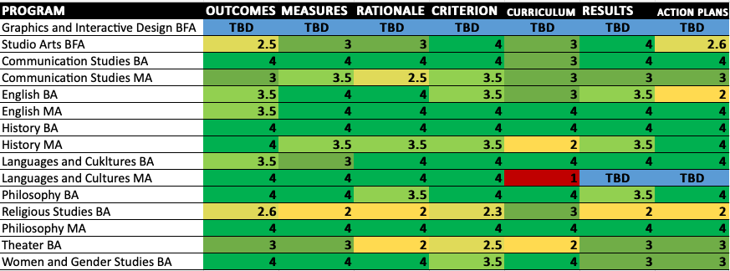
**TBD indicates assessment plan in development or under review.
College of Business and Public Management

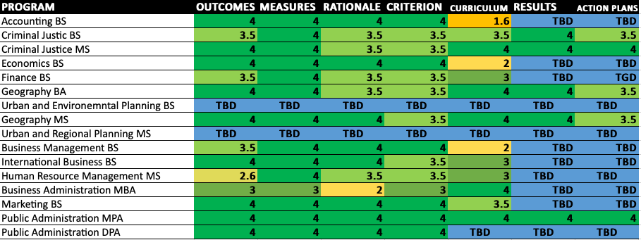
*TBD indicates assessment plan in development or under review.
College of Health Sciences

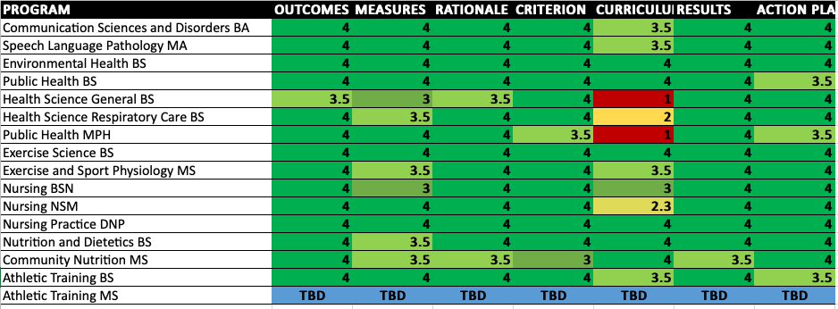
*TBD indicates assessment plan is in development or under review.

College of Sciences and Mathematics

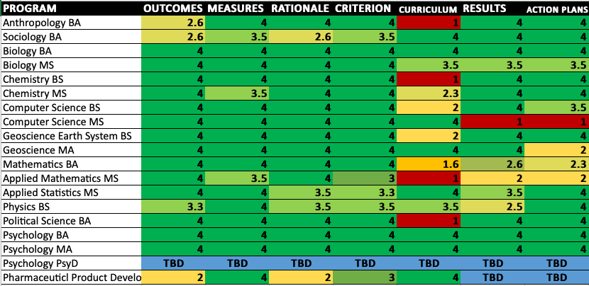
*TBD indicates assessment plan is in development or under review.

University College

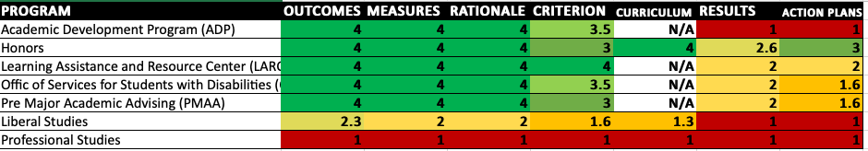

Wells School of Music

