Career Development Module Completion & Badge Submission
Page 1 = Instructions for Faculty and Page 2 = Student Assignment

Faculty Instructions
- Decide which Career Development D2L module(s) you want students to complete. Available modules include:
    - Introduction to Career Readiness
    - Resumes/Cover Letters: Storytelling & Content Basics
    - Executing a Job and Internship Search
    - Interview Preparation
    - Career Connections: Networking

**Reminder: Insert the chosen module(s) into the student instructions

- Create a D2L assignment for students to submit their badge for proof of completion.
  - An easy structure is using “Text Submission” under the Submission & Completion options. Students can then add the hyperlink for their badge.

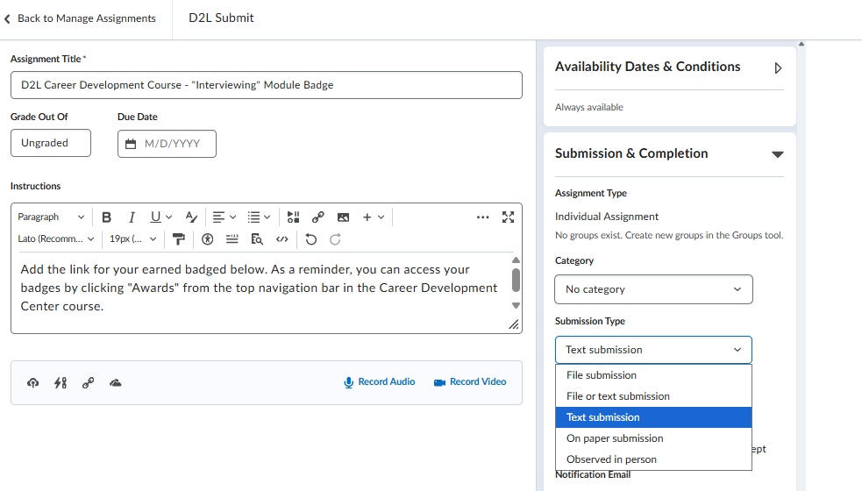

- Decided where to add assignment instructions and submission to your D2L course for students to access.

Note: If you are not using virtual submission options, students can print a copy of the badge.

Career Development Module Completion & Badge Submission

This assignment is designed to help you build key elements and skills in your career readiness toolkit by completing a designated module in the Career Development D2L course. You will demonstrate completion by submitting your earned badge.

Steps to Complete the Assignment:
- Enroll in the Career Development Center Course:
  - Click here and log in to D2L using your WCU credentials
  - Select Enroll in Course – your enrollment is automatic, and the CDC Course will now be available in ‘My Courses’
- Complete the Assigned Module(s):
  - Your Module(s) for This Assignment: [Faculty: Insert selected module(s) here]
  - Read all content and complete all module activities.

- Earn Your Badge:
  - After completing the module, you will automatically receive a badge.
  - Click "Awards" from the top navigation bar to access your badges.
  - Select the Share button under your earned award and click ‘Copy Link’
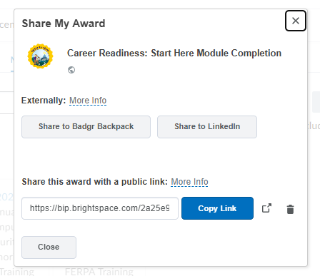
*Note: if more than one module is assigned, you will need to copy the link for each badge

- Submit Your Badge in This Course:
  - Navigate to the assignment in [Faculty: Insert course title] D2L course
  - Insert the public link for your badge and click submit.

