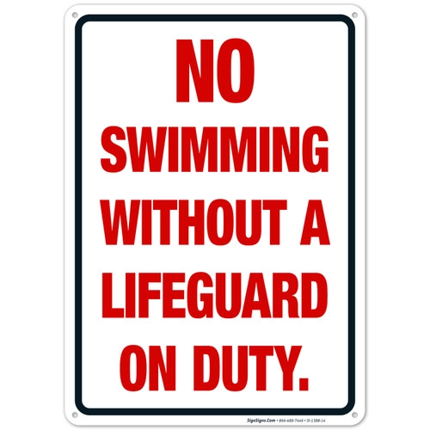**West Chester University**

**Fall Semester 2025**

North Campus REC SWIM Schedule

NO Rec Swim on South Campus

|  |  |  |  |  |  |  |
| --- | --- | --- | --- | --- | --- | --- |
| Monday | Tuesday | Wednesday | Thursday | Friday | Saturday | Sunday |
| 12:00 –  2:00 PM | 12:00- 2:00 PM | 12:00 –  2:00 PM | 12:00 - 1:30 PM | 12:00 – 2:00 PM | 12:00-3:00 PM | 12:00- 3:00 PM |
| 6:30 –  9:00 PM | 6:30 –  9:00 PM | 6:30 –  9:00 PM | 6:30 –  9:00 PM | X | X | X |

**Present University IDs to Lifeguards for Admittance**

**Please rinse off before entering the pools.**

**First Day of REC SWIM** – Monday September 8th / **Last Day of REC SWIM** December 7th.

**Please check WCU Campus Recreational website for announcements.**

Contact Pool Management (Victor Polyakov) – [vpolyakov@wcupa.edu](mailto:vpolyakov@wcupa.edu)